GOVERNMENT AIZAWL COLLEGE
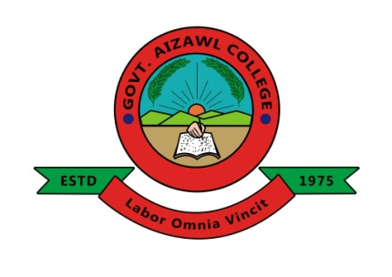

ANALYSIS REPORT
——————————————
FEEDBACK SURVEY OF PARENTS:
2019 - 2020

Curricular Aspects Cell
2019 - 2020
Analysis Report: Feedback Survey of Parents

1. It is commonly known among parents (77.3%) that the College conducts Parent-Teacher meets regularly.

2. Most parents (97.7%) agree that the College environment is favourable for the overall development of their ward.
2.3%

3. The feedback survey has not revealed anyone facing financial issues regarding payment of fees. However, this finding does not imply that all students of the College are financially secure.

4. More than a third of the parents surveyed (68.2%) rates the quality of the teachers as ‘Good’.
1.1%

5. The academic results of the College elicit a lukewarm response with 73.9% of the respondents giving an ‘Average’ rating and less than a quarter (20.5%) rating it as ‘Good’.
5.7%

6. Regarding the maintenance of academic rigour and discipline, 30.7% of the respondents believe the College does a ‘Good’ job while 64.8% believe there is room for improvement by preferring to give it an ‘Average’ rating.

4.5%

7. A large majority (97.7%) of the parents surveyed hold positive views about the way the College handles students’ grievances.
2.3%

8. Regarding the personal mentoring received by students from their teachers, 95.4% of the parents surveyed offer positive replies. However, concerted efforts must be made to convert the ‘Average’ ratings into ‘Good’ ones.

4.5%

9. Most parents (93.2%) indicate that they would like to receive regular updates about their ward’s academic performance in the College.

6.8%

10. Half of the respondents agree that the online readmission process introduced by the College provides an educational purpose for the students.
4.5%

11. Ninety two percent (92%) of the parents surveyed agree that students show improvements in their personality / moral values / soft skills / maturity after joining the College.
6.8%
1.1%

